[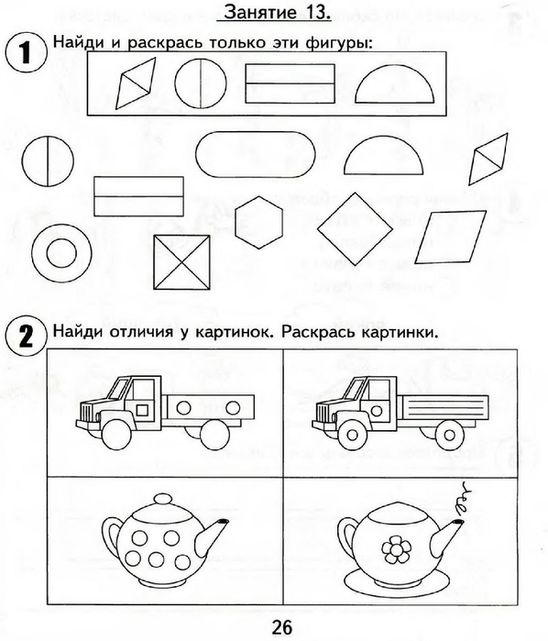](https://img0.liveinternet.ru/images/attach/c/7/94/296/94296030_large_0027.jpg) [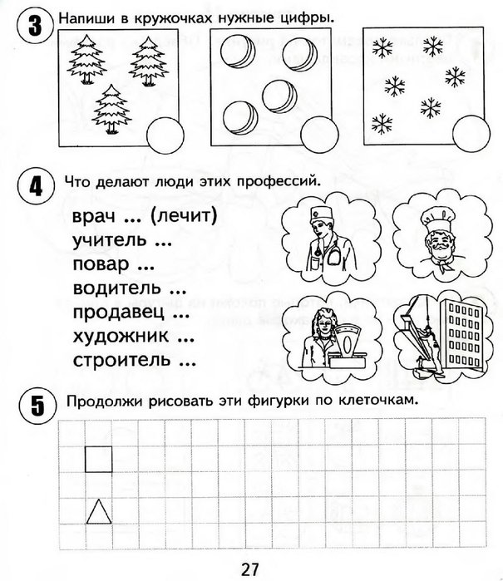](https://img1.liveinternet.ru/images/attach/c/7/94/296/94296031_large_0028.jpg)