[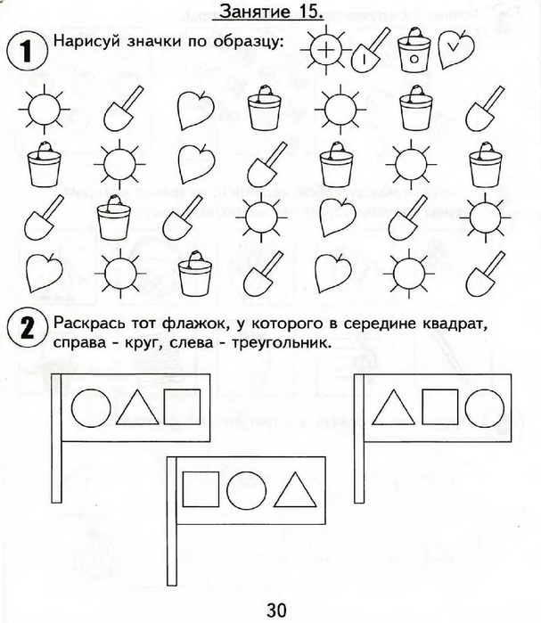](https://img0.liveinternet.ru/images/attach/c/7/94/296/94296034_large_0031.jpg) [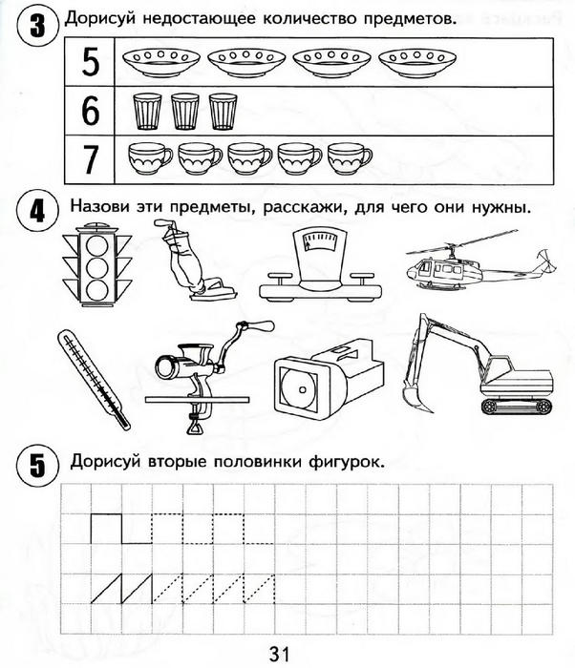](https://img1.liveinternet.ru/images/attach/c/7/94/296/94296035_large_0032.jpg)