[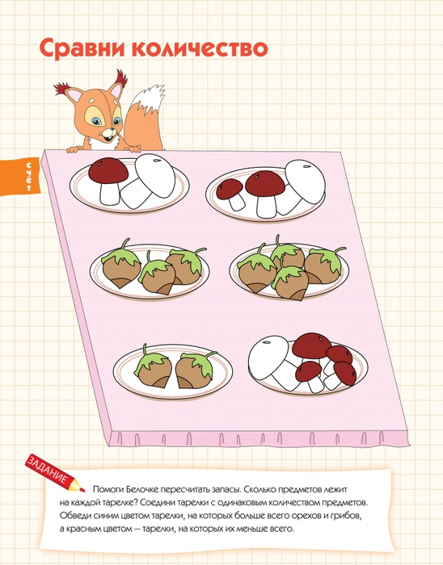](https://img0.liveinternet.ru/images/attach/c/7/96/540/96540754_large_4979214_12_1.jpg) [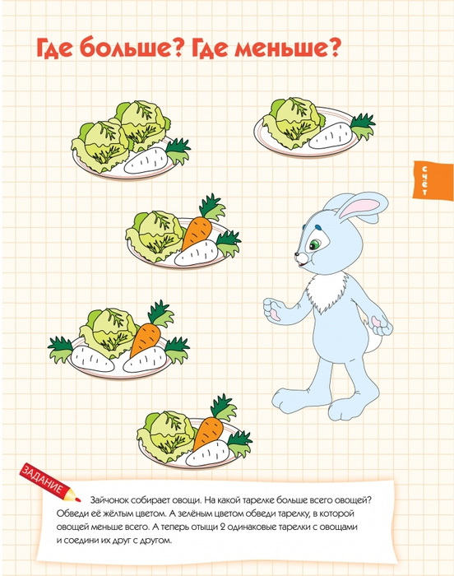](https://img1.liveinternet.ru/images/attach/c/7/96/540/96540755_large_4979214_13_1.jpg)