[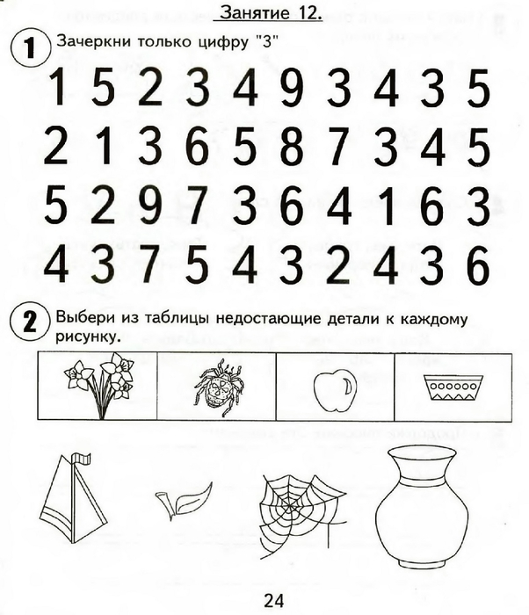](https://img0.liveinternet.ru/images/attach/c/7/94/296/94296028_large_0025.jpg) [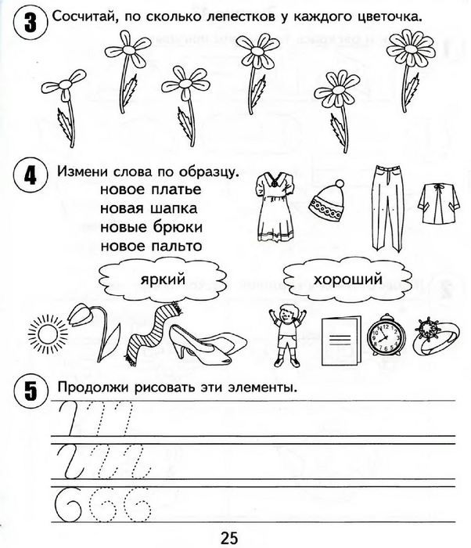](https://img1.liveinternet.ru/images/attach/c/7/94/296/94296029_large_0026.jpg)