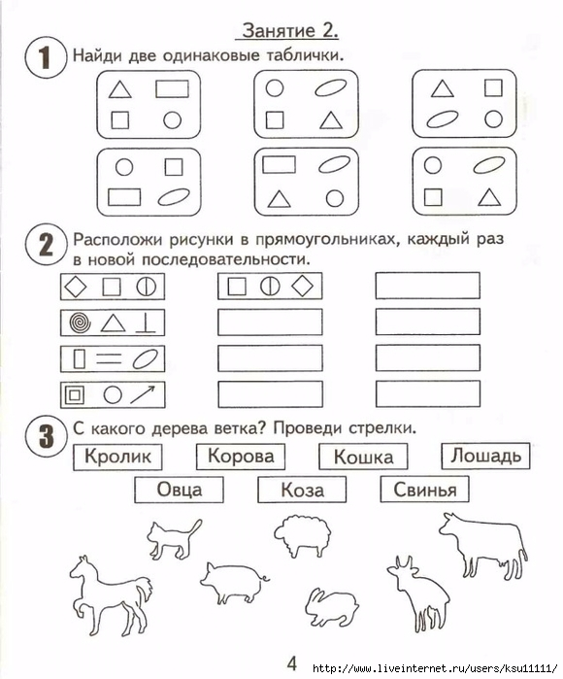[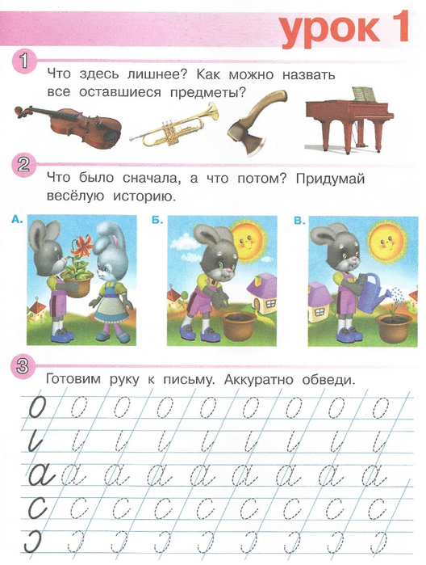](https://img0.liveinternet.ru/images/attach/c/7/98/52/98052778_large_Scan0003.jpg)

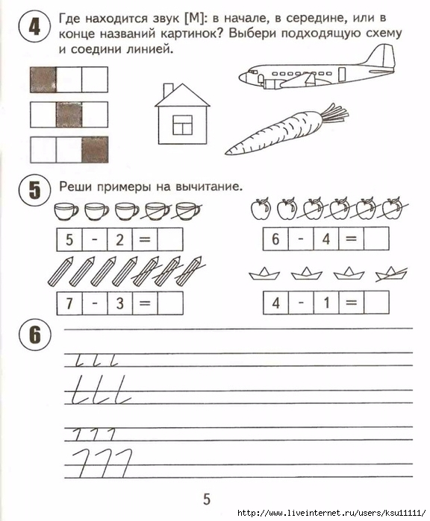 [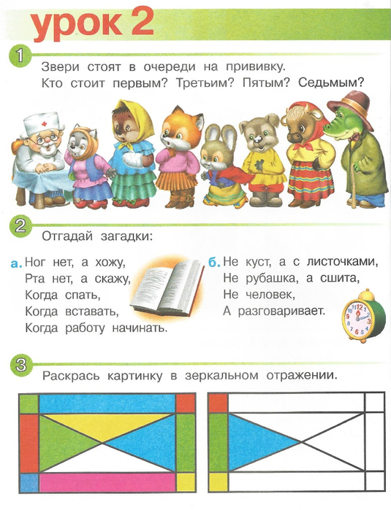](https://img1.liveinternet.ru/images/attach/c/7/98/52/98052781_large_Scan0004.jpg)