[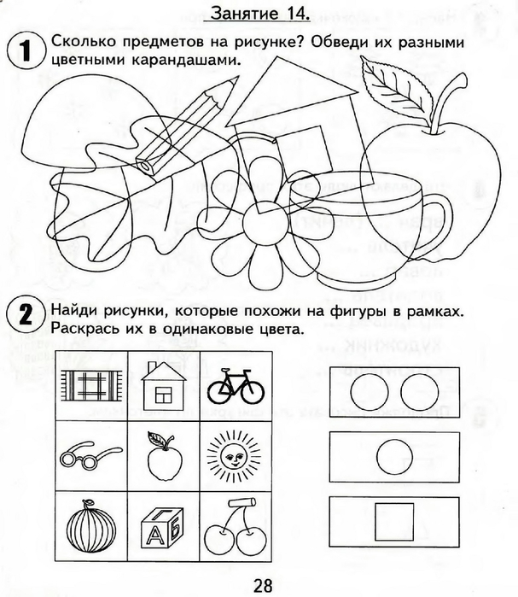](https://img0.liveinternet.ru/images/attach/c/7/94/296/94296032_large_0029.jpg) [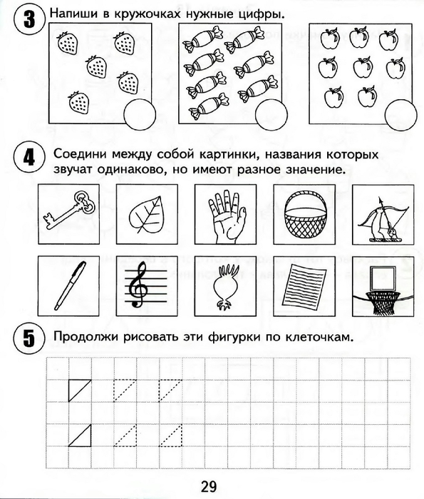](https://img1.liveinternet.ru/images/attach/c/7/94/296/94296033_large_0030.jpg)